Unit 12 Airport departures

Take off
1 How many airports have you been to?
2 What's your favorite airport? Why?
3 Where do you think would be the most interesting place to work in an airport? Where would be the most dangerous?
Where in the world?
1 Does the plan show the departures level or the arrivals level?
2 What happens when travellers depart from and arrive at an airport? Divide the following into departure and arrival procedures and put them in the order in which they occur.
a. passport control g. baggage reclaim
b. board the plane h. check-in desk
c. security check i. departure gate
d. immigration j. get off the plane (disembark)
e. departure lounge k. customs
f. arrivals hall
3 Is the airport similar to your local airport?

In this unit
• airport facilities, services, and procedures
• responding politely to questions and requests
• airport dialogues
• giving orders, stopping people doing something

Vocabulary
Airport facilities and services
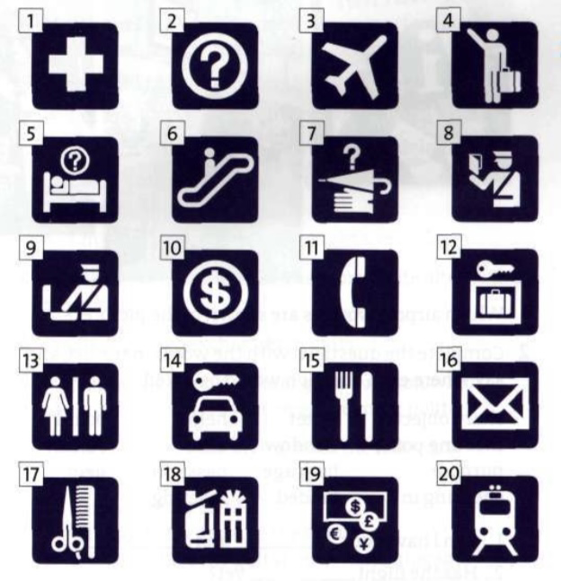
1 What do the symbols of airport facilities represent?

2. Which symbol represents a place where
a you can store your baggage?
b you can get emergency medical treatment?
c you can rent a car?
d you may have your luggage searched?
e you might find something you have lost?

3. Match the words in the list with the symbols.
a note reservauons j lost property r lifts
b immigration k smoking area s bar
c luggage trolleys 1 post office t first aid
d restaurant / café m information u customs
e bureau de change n hairdressers v toilets
f baggage store o escalator w telephones
g email and Internet p departures x arrivals
h railway station q shops y car rental
i cashier

4. Work in pairs. Five services or facilities do not have a symbol. Design suitable symbols, and compare with the class.

Reading
Working in airports
1.Make a list of the different jobs there are in an airport.
Which job would you most /least like to do?
2.Read the article for people training in tourism and complete the missing sections with the extracts below.
Inside tourism: Getting an airport job
When people think about working in the air travel industry they usually think of flight attendants and pilots - the cabin crew and the flight crew. But there are many other job opportunities at airports. These can include working in the various________(1) or more
specifically tourism related services, such as the________(2) The work of the airline ground crew includes________(3) until they board the plane and are handed over to the
cabin crew. Most employers will expect ground crew to have a good basic education, including a good level of English. You should have a pleasant helpful personality.
Previous experience in a job which involves working with the public
(such as________4) is preferred.
As with travel consultants and cabin crew, ground crew are usually employed on permanent contracts but often work shifts. Free and discounted flights are usually
offered after a probationary period.
Some jobs at the airport do not involve contact with the public.
Examples of these are________(5).

For more information on getting a job at an airport, you should…

a information desk, the bureau de change, the check-in desk, the security check, and customs and immigration.
b shops, hotels, restaurants, and banks.
c baggage handlers, mechanics, and drivers.
d restaurants, bars, and shops.
e selling tickets, checking in passengers, dealing with enquiries, and supervising passengers.

Listening
An airport worker
Ali Ghoshal was born and brought up in Pakistan. He now works at London's Heathrow airport as an aircraft technician as part of the turn-around team.

1. Listen to the interview and answer the questions.
1 What does the turn-around team do?
2 How many people are in the team?
3 Does Ali have any special qualifications?
4 What is the main stress in his job?
5 What does he like most?
6 What does he like least?
7 Does he get any special 'perks' or benefits?
8 What does he plan to do in the future?

2. Listen again and complete the questions that the
interviewer asks.
1 What does__________________________________?
2 How many__________________________________?
3 What qualifications___________________________?
4 Is it________________________________________?
5 What do you_________________________________?
6 And________________________________________?
7 So you're____________________________________?
8 Do you______________________________________?
Find out
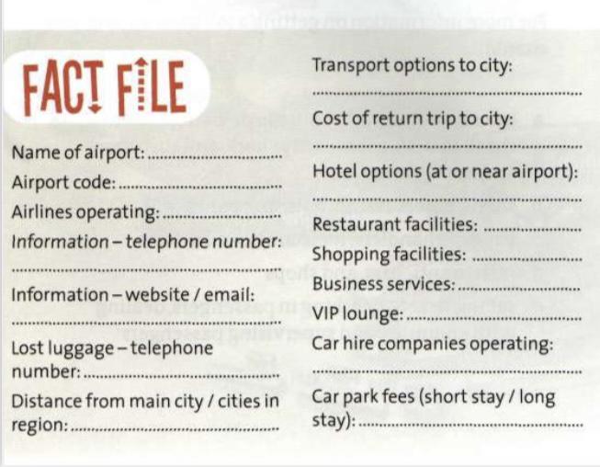
Find out about your nearest airport and complete the fact file.

Vocabulary
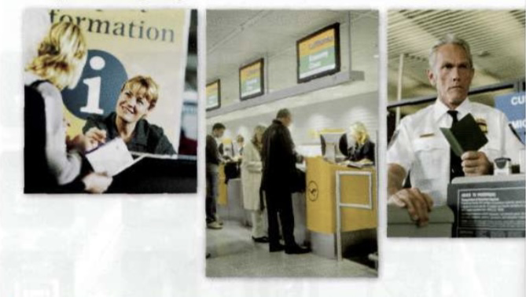
Airport language

1 Which airport workers are shown in the pictures?
2 Complete the questions with the words in the list, and say where each question would be asked.

sharp objects ticket help board
meeting point window aisle suitcase
purpose baggage passport help
checking in landed meeting

1 Can I have your________and________?
2 Has the flight _________ yet?
3 Did you pack your ________ yourself?
4 Are you _________ someone?
5 What is the ________ of your visit ?
6 Are you carrying any ________ in your hand luggage?
7 Could you ________ me?
8 Can I ________ you?
9 Has your ________ been in your possession at all times?
10 Are there any_________ seats available?
11 Can you tell me where the __________ is?
12 Is it too late to _________ the plane?
13 Are you _________ any bags today?
14 Would you like an ________ seat?

3 Which questions are asked by passengers?

The world's busiest airports
The world's busiest airports in 2002 (millions of passengers)
1 Atlanta (ATL). 75.8
2 Chicago (ORD). 66.8
3 Los Angeles (LAX). 61.0
4 London (LHR). 60.7
5 Tokyo (HND). 58.7
6 Dallas / Fort Worth (DFW). 55.2
7 Frankfurt (FRA). 48.6
8 Paris (CDG). 48.0
9 Amsterdam (AMS). 39.5
10 Denver (DEN). 36.1

• Language spot
Responding politely to questions and requests
1 Match the following responses by airport workers with the five passenger questions in Vocabulary 2.
a Certainly. How can I help?
b I'm afraid it is. The cabin doors have been locked.
c No, I'm sorry, it hasn't. There's been a delay.
d Yes, of course. It's just over there, next to the newsagents.
e I'm afraid there aren't. The flight's very full

2 Which expressions are used as more polite alternatives to yes and no?
3 Practise the five exchanges in pairs.
4 Note how the airport worker gives a reason when
saying no. This makes the negative more polite.
Think of a reason for saying no to the following
questions:
1 Can we smoke here?
2 Can I go to the front of the queue?
3 Is it OK to take my guitar on as hand luggage?
4 Is there any chance of an upgrade to First Class?
5 In pairs, practise the four situations above.
6 Write down three or four questions that a passenger might ask - include at least one where you would expect a negative response. Ask your questions to a partner and act out the dialogue.

>>Go to Grammar reference p.126

Listening
Two airport dialogues
1 Listen to these two airport dialogues.
- Where do they take place?
- Note down the flight numbers, gate numbers, and cities that are mentioned.

2 Listen again and complete the dialogues
CONVERSATION A
A Could you __________ (1)? I'm trying to find out if a flight has arrived or not.
B __________ (2)Are you meeting someone?
A Yes, my brother. He was due in on ___________(3) from _________(4). Has it arrived yet?
B Yes, ___________ (5) Let me check the _________(6) Here it is. It arrived an hour ago.
He should be coming through ________ (7) about now.
A Right, I'll go there _________ (8) , you say?
B Yes, or if he's not at _________ (9) try the ________(10)
A That's a good idea. Can _________ (11) where the meeting point is?
B ________ (12). It's just over there, next to the newsagents.
A Thanks for your help.
B _________ (13)

CONVERSATION B
C Hello. Can I have your passport and _________ (1)?
D Here you are.
C Thank you. Are you ________ (2) any bags today?
D Just this one. The other's ________ (3)
C Can you put it on the ________ (4) ? Thanks. Did you __________ (5) yourself?
D Yes, I did.
C Has anyone _________ (6) your luggage in any way?
D No, they haven't.
C Are you carrying any _________ (7) such as nail scissors?
D No, I'm not. Can _________ (8) if there are any window seats available?
C No, __________ (9) there aren't. The flight's very full. Would you like an aisle seat?
D Yes, that'll do.
C OK. Here's your _________ (10) You'll be boarding through _________ (11) in 30 minutes. Have a _________ (12) .
D Thank you.

Speaking
The check-in and information desks
Work in pairs. Student A, look at p. 113. Student B, look at P.114.

compensation (n) money that you pay to sb because you have injured him/her or lost or damaged his/her property.
refund (n) a sum of money that is paid back to you, especially because you have paid too much or you are not happy with sth you have bought.
volunteer (n) a person who offers or agrees to do sth without being forced or paid to do it.

Reading
Air passenger rights
1 What things can go wrong for air passengers? Think about: before boarding, during the flight, after landing.
2 Now look at the front page of a European Commission leaflet about air passengers' rights.
What do you think air passengers have a right to in each of the four categories?
If you are denied boarding, the airline must…
If your flight is cancelled, the airline must…

Having problems with your journey?
The European Union (EU) has strengthened your rights.
Here are the most important.
IF THINGS GO WRONG…
The EU has created a set of rights to ensure air passengers are treated fairly.
The airline operating your flight is responsible for transporting you and your baggage, and must respect your rights.

DENIED BOARDING AND CANCELLATION
If you are denied boarding or your flight is cancelled, the airline operating your flight must offer you financial compensation and assistance. These rights apply, provided you check in on time, for any flight, including charter:
- from an EU airport, or
- to an EU airport from one outside the EU, when operated by an EU airline

DENIED BOARDING
When there are too many passengers for the seats available, an airline must first ask for volunteers to give up their seats in return for agreed benefits. These must include the choice of either refund of your ticket or alternative transport to your destination. If you are not a volunteer, the airline must pay you compensation of:
• €250 for flights of 1,500 km or less
• €400 for longer flights within the EU, and for other flights between 1,500 km and 3,500 km
• €600 for flights over 3,500 km outside the EU.
The airline must also give you:
• a choice of either a refund or your ticket (with a free flight back to your initial point of departure when relevant) or
• alternative transport to your destination, and meals and refreshments, hotel accommodation when necessary (including transfers), and communication facilities.

CANCELLATION
Whenever your flight is cancelled, the operating airline must give you:
• a choice of either a refund or your ticket (with a free flight back to your initial point of departure when relevant) or
• alternative transport to your destination, and meals and refreshments, hotel accommodation when necessary (including transfers), and communication facilities.
The airline may also have to compensate you at the same level as for denied boarding, unless it gives you sufficient advance notice. You shall be informed about alternative transport.

3 Work in two groups. Group A, read about Denied boarding' and 'Cancellation'. Group B, read about 'Long delays' and 'Baggage'.
1 Check to see if your answers in 2 were correct.
2 Find out the level of compensation that the airline must provide.
4 Explain what you have discovered to a student from the other group.

Refunds may be in cash, by bank transfer or cheque or, with your signed agreement, in travel vouchers, and must be paid within seven days.
If you do not receive these rights, complain immediately to the airline operating the flight.
LONG DELAYS / IMMEDIATE ASSISTANCE
If you check in on time for any flight, including charters: from an EU airport, or to an EU airport from one outside the EU, when operated by an EU airline and if the airline operating the flight expects a delay
• of two hours or more, for flights of 1,500 km or less
• of three hours or more, for longer flights between 1,500 and 3,500 km
• of four hours or more for flights over 3,500 km the airline must give you meals and refreshments, hotel
accommodation when necessary (including transfers), and communication facilities.
When the delay is five hours or more, the airline must also offer to refund your ticket
(with a free flight back to your initial point of departure when relevant).
If you do not receive these rights, complain immediately to the airline operating the flight.
BAGGAGE
You may claim up to €1,000 for damage caused by the destruction, damage, loss, or delay of your baggage on a flight by an EU airline, anywhere in the world. If the airline does not agree with your claim, you may go to court.
For damage to checked-in baggage, you must claim in writing within seven days of its return and for delayed baggage within 21 days of its return.

Speaking
Incident and action log

- In groups, look at this airline 'incident and action log' For each of the incidents, decide if the airline acted correctly according to the European Commission leaflet.
- Have any incidents like this ever happened to you, or someone you know? Tell the rest of the group about it.

Incident | Passenger action | Airline action
1 Five passengers overbooked on flight from London to Paris | No passengers volunteered to alternative flight | Passengers selected randomly and put on alternative flight (three hours later). Free  meal and drink given as compensation, plus  €50 voucher for the Gift Shop.
2 Flight from Rome to  New York cancelled at last minute due to technical problems | All passengers moved on to flight on next day | Hotel accommodation given (plus meals and transfers). In addition compensation of €250 paid to each passenger.
3 Flight from Zurich to Dublin delayed by one hour and 30 minutes | n/a | Free drink given to all passengers
4 Flight from Madrid to Tokyo delayed by seven hours | Nearly all passengers agreed to wait, but two wanted to cancel and get a refund | Meals and refreshments given, plus offer of airport hotel accommodation. No refunds given
5 Baggage lost on Bonn to London flight | Passenger claimed €2,000 compensation | Passenger given €1,000 compensation and a 10% discount voucher for a future flight
6 Suitcase damaged, and some contents broken and missing (on same flight as 5) | Passenger made verbal report to clerk, but written claim received eight days later | Passenger given €100 compensation

Customer care
Care or control?
1 At airports customers must be cared for, but they must also be controlled. Can you think of examples of where care and control are needed in an airport?
2 What are the safety or security risks in the cartoon?
3 What should the member of staff say to the passenger?

Listening
Two more airport dialogues
1 Work in pairs. What problems can passengers have at airports (a) with their luggage, (b) if they arrive late?
2 Listen to two dialogues.
1 In which dialogue is the airport employee showing care and in which is she showing control?
2 Make notes on the problems.
3 What solution(s) is / are offered in each case?
3 Listen again. Complete the sentences. You may need more than one word per space.
1________ to the oversized baggage desk- sometimes bags go there________ .
2 Yes, I________.
3 In the meantime,________ fill in this form, so we can trace it?
4 If you________ wait over there,________ this out.
5 Excuse me, sir. I'm________ ,but you________ through there
6 I'm afraid________ -the cabin doors have been shut.
7 Sir,_________ the barrier! If you do,_______ call security.
8 Now, ________ my colleague at the airline desk over there, ________ that you get on the next available flight.

Language spot
Giving orders and stopping people doing something
1 Look at the different language areas used in the table below.

Language area

(Giving an order/instruction) (Stopping someone doing something)
1 Imperative. Take off your jacket! Don't smoke here!
2 Can you/could you? Can you take off your jacket? Can you please not smoke here?
3 I'm sorry / I'm afraid I'm sorry, but you'll have to take off your jacket. I'm sorry, but you can't smoke here. or I'm afraid this is a no smoking area
4 If clause If you take off your jacket, we can let you through. or
If you could just take off your jacket.
If you want to smoke, you'll have to go to the special area.

2 Which of the examples seem firm but polite, and which seem firm but direct?
3 Find other examples in the listening script on p. 136.
4 Write similar sentences for these situations.

»› Go to Grammar reference p.126

Pronunciation
When we deal with the public we usually want to sound firm but polite.

1 Listen and decide whether these sentences are (a) firm but polite or (b) firm but too direct.
- (b)
1 Can you take off your jacket?
2 Can you take off your jacket?
3 I'm sorry, but you can't smoke here.
4 I'm sorry, but you can't smoke here
5 If you could just take off your jacket.
6 If you could just take off your jacket.
7 I'm afraid this is a no-smoking area.
8 I'm afraid this is a no-smoking area.

2 Listen and repeat. Be firm but polite.
3 Try saying the following in a firm but polite voice.
1 Can you put your bag in the tray?
2 If you could take you watch off.
3 I'm sorry, but you can't take photos here.
4 I'm afraid you can't use your mobile here.

Speaking
Controlling passengers
1 Look at the situations. For each one, decide why it is wrong, give a possible reason for the passengers behaviour, and say what level of firmness is required.
1 Passenger not waiting behind line at immigration
2 Passenger not wanting to take off shoes at security check
3 Passenger refusing to open suitcase at customs
4 Passenger going through a door marked 'Private'
5 Think of another
2 In pairs, role-play the situations. Passengers should be insistent; employees should be firm but polite.

Checklist
Assess your progress in this unit. Tick (/) the statements which are true.
- I can describe airport facilities and services.
- I can respond politely to questions and requests.
- I can understand and participate in a variety of airport dialogues.
- I can give orders and stop people doing something.

Key words
Airport staff
baggage handler
cabin crew
ground crew
mechanic
Airport places and procedures
aisle departure lounge
baggage reclaim escalator
barrier immigration
bureau de change lost property
customs passport control
departure gate security check
Other nouns
boarding pass scales
limousine seatbelt
passenger flow trolley
Verb
Land

Next stop
1 What encounters have you had as a tourist or visitor in any of these places: a travel agency,
a tourist information office, an airport, a hotel, or when using a website?
2 Who did you meet?
3 How did they help you? How do you rate the service they provided?

