Unit 2 Customer information
In this unit you will
- give information to customers
- talk about hotel facilities and services
- tell customers where facilities are.
▀ Starter
Look at the pictures. What facilities and services does this hotel offer?
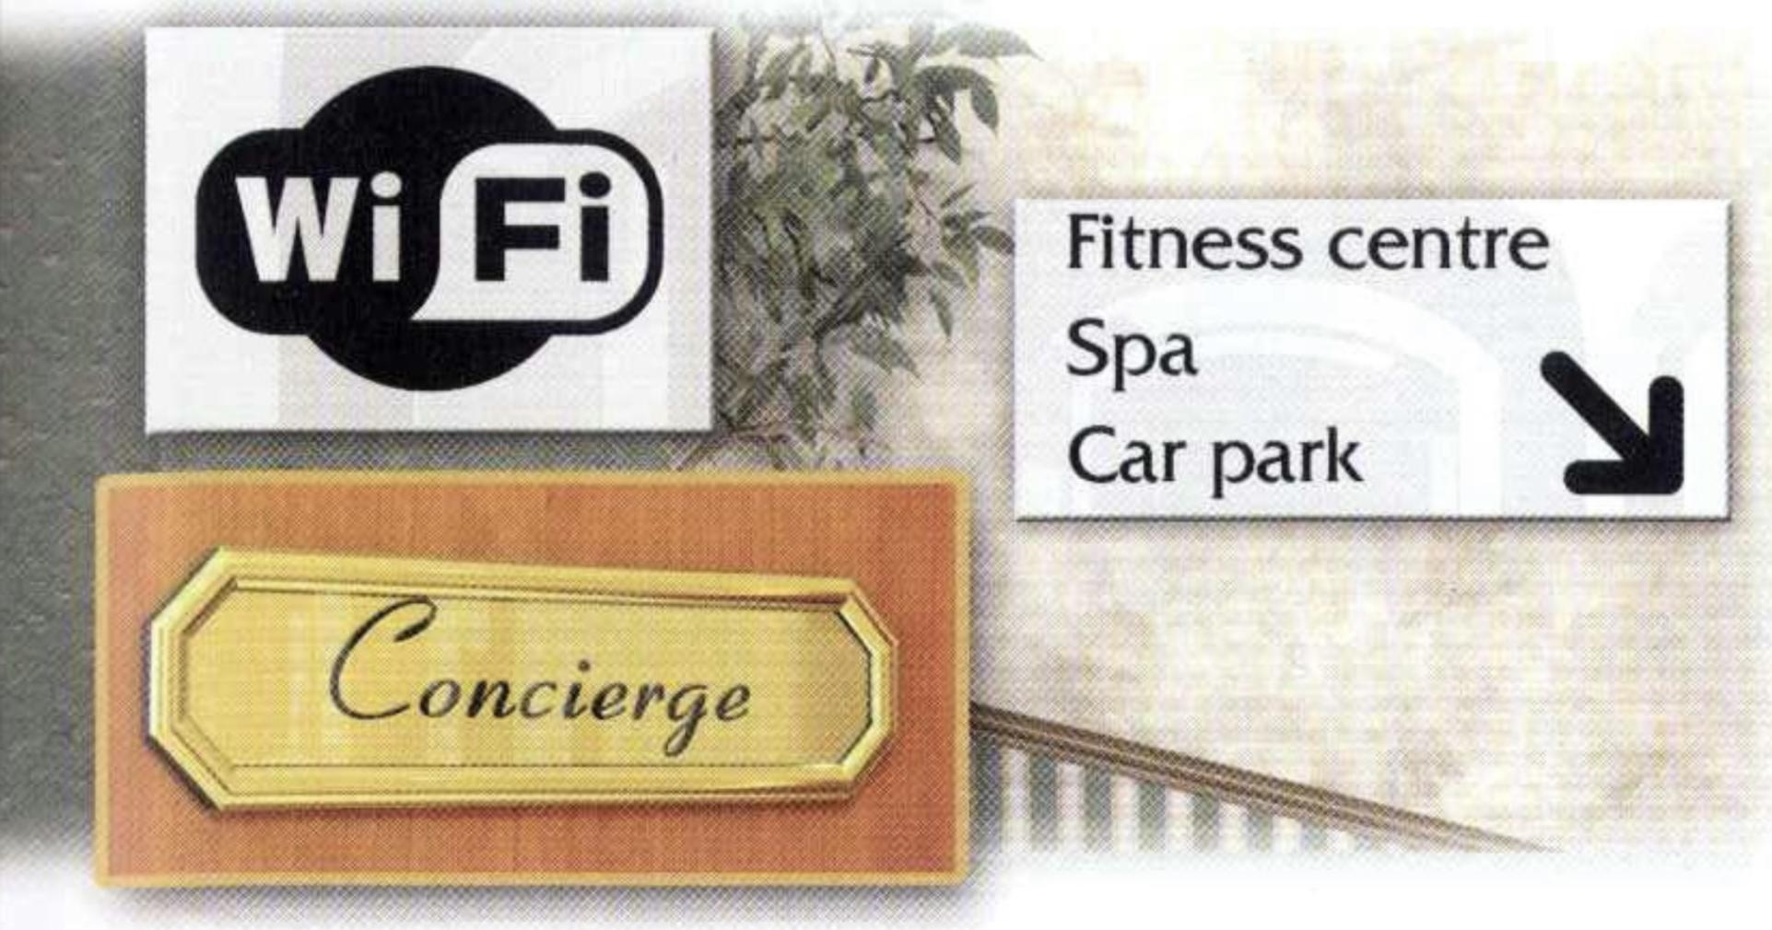

▀ Listening Giving information
- 🎧 2.1 Listen and tick (✔) the facilities and services that you hear.
1 ☐ airport transfer 5 ☐ car park
2 ☐ fitness centre 6 ☐ car rental desk
3 ☐ hotel restaurant 7 ☐ restaurant recommendation
4 ☐ business centre 8 ☐ Internet access

- 🎧 2.1 Listen again and complete the sentences.
1 How …………………. from the airport to the Grand Marina?
2 There’s a shuttle bus ………….. the airport direct …………….. the hotel.
3 Where does it ………………….. ?
4 And ……………………… does it take?
5 Great. Um … …………………….. business services?
6 It’s …………………… ground floor, opposite reception.
7 I’d like to ……………… a car for a few days.
8 Just …………… the …………………………… desk, next to reception …

- Work with a partner. Look at the hotel information. Take turns to ask and answer about these things.
● get from airport? ● hire a car?
● how long? ● fitness centre?
● charge for bus? ● restaurants near hotel?

Hotel Nathale
FREE AIRPORT TRANSFER — 50 minutes — shuttle bus direct to hotel — outside Terminal 1, in front of taxi of taxi rank
Other services

CAR RENTAL DESK — opposite reception
FITNESS CENTRE — ground floor, next to swimming pool
RECOMMENDED RESTAURANTS: Fargo’s, Italian — opposite hotel / Comptoir, French — Rue des Bains

▀ Language study
！Expressions to learn
There’s a shuttle bus from … direct to …
The bus stop is just outside the … , opposite the
We offer a free airport transfer to all our guests.
It’s on the ground floor, opposite …
It’s open 24 hours.
We’ll arrange that for you.
Can you recommend a restaurant near the hotel?
I can recommend Gino’s … It’s very good.

！New words to use
business centre hire shuttle bus
car rental main taxi rank
client on site tourist attraction
direct roof terrace transfer
facilities separate wheelchair access
gift shop service
» Glossary page 102

！Language check
Is there?/Are there?, There’s/There are, There isn't/ There aren’t
Remember to use the correct form of be.
Examples
Is there a transfer from the airport?
Yes, there’s a free bus. / No, there isn't a bus to the hotel.
Are there ground floor rooms? Yes, there are. / No, there aren’t.
» Language review page 86

1 Work with a partner. Look at the pictures on pages 6 and 7 again. Take turns to ask and answer about these things.
1 a car rental service 6 business services
2 a swimming pool 7 gift shops
3 lifts 8 ahair salon
4 parking spaces 9 translation services
5 Internet access 10 information about tours

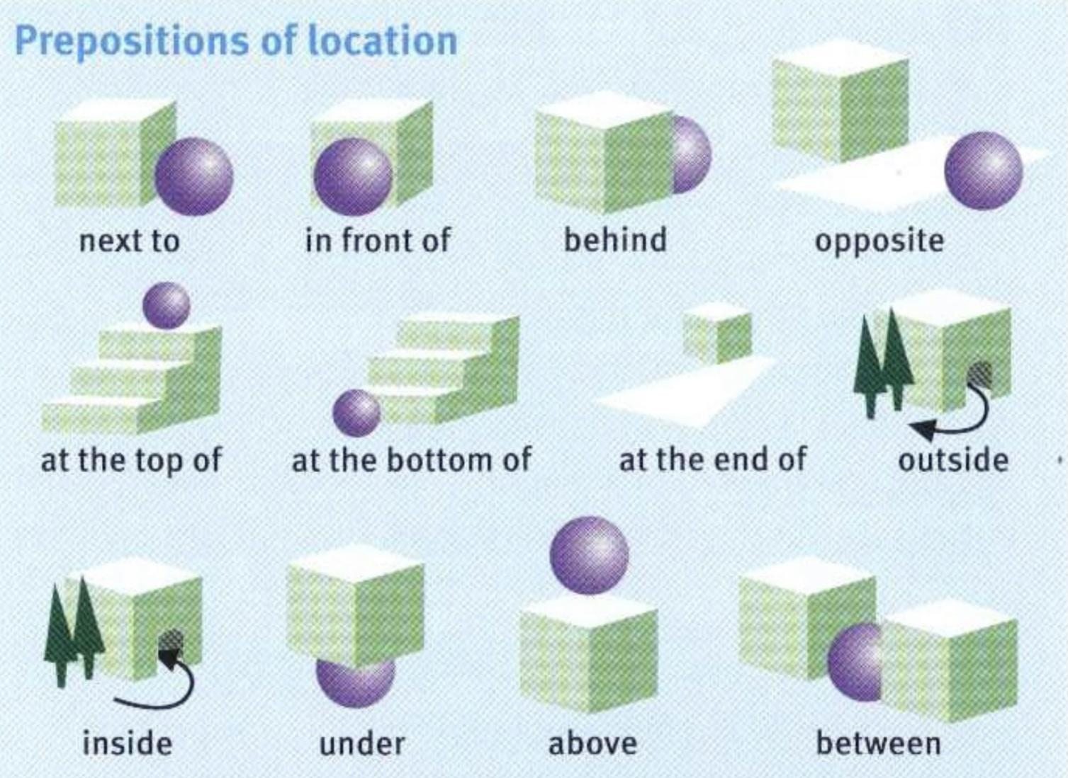

2 Look at the pictures and complete the sentences. Use the correct preposition from the list above.

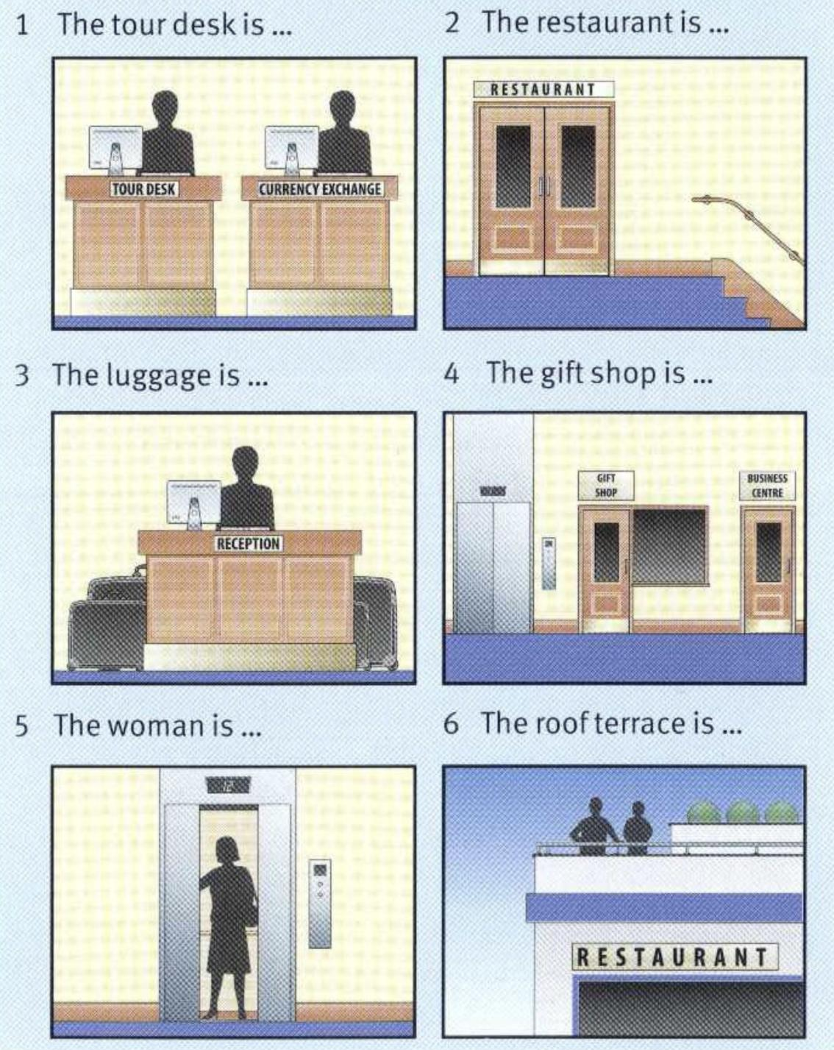

▀ Listening Services and facilities
- 🎧 2.2 Listen to the hotel presentation and complete the list of services and facilities. Then listen again and check.
▀ near city …………….¹ ▀ …………….⁹ desk
▀ near ……………..² mail ▀ lifts
▀ near ……………………….³ attractions ▀ wheelchair …………….¹⁰
▀ ……………...⁴ front desk ▀ air conditioning
▀ express …………….⁵ ▀ …………………….¹¹ Internet access
▀ airport ……………………⁶ ▀ …….…………….¹² movies
▀ free ……………..⁷ ▀ …………….¹³ tub and shower
▀ business centre ▀ …………….¹⁴ gym and sauna
▀ …………….⁸ exchange
▀ car rental desk

- Match the items in 1 to these categories.
1 hotel service: ………………………………………………….
2 room facility: ………………………………………………….
3 location: ……………………………………………………….
4 hotel facility: …………………………………………………..

- Work with a partner. Think of five more services and facilities available in a 5-star hotel.
Activity
You’ve been asked to give a presentation about your hotel to a company interested in using the hotel for its clients.

Think of a hotel that you know, find out information about a hotel on the Internet, or use the information on page 60. Prepare a short presentation (60 words +) to give to the class using these headings.

Location General facilities Room facilities Services
Example
LOCATION: The Plaza Hotel is in the city centre near the main shopping streets ang important tourist attractions.
GENERAL FACILITIES: There are 140 ensuite rooms with two restaurants and a terrace bar …
ROOM FACILITIES: All the rooms have air conditioning with minibars, safe deposit boxes, pay-per-view TV …
SERVICES: There is a 24-hour business centre and there are gift shops in the the main reception area …

